HTNO:2403A51305

Batch:13

Assignment 2.3

**Task Description#1**

Use Google Gemini in Colab to write a function that reads a CSV file and calculates mean, min, max

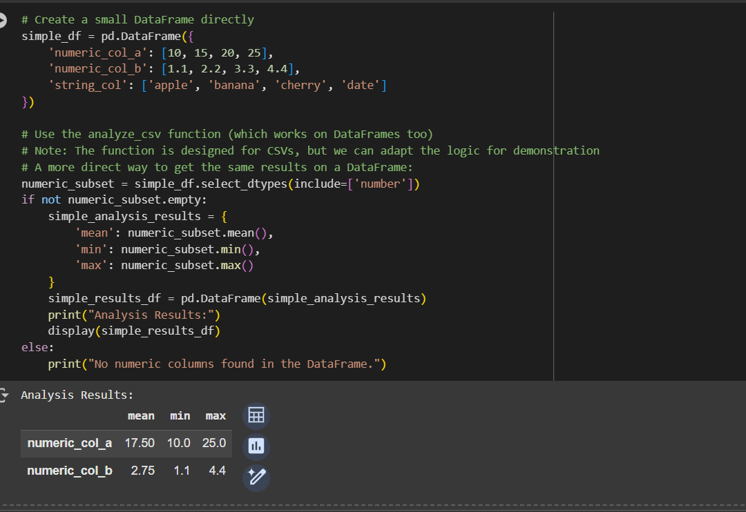

Output:



**Task Description#2**

Compare Gemini and Copilot outputs for a palindrome check function

GEMINI AI:

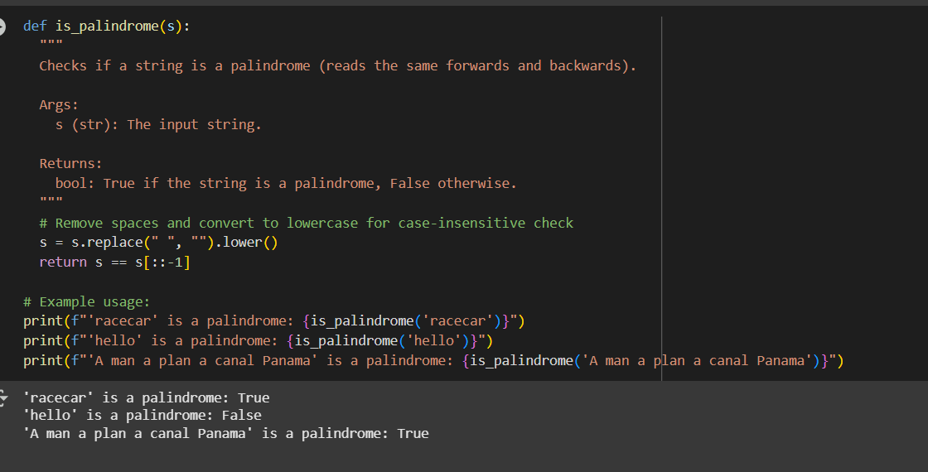

Output:



COPIOLOT:

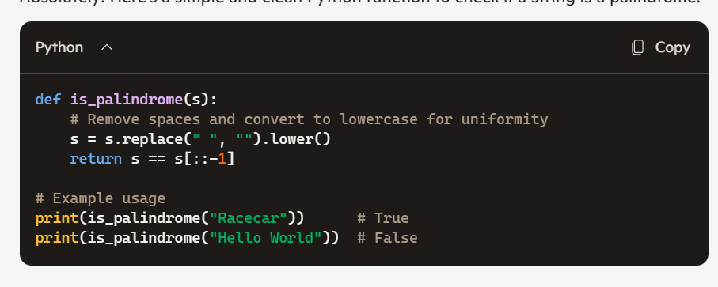

**Task Description#3**

* Ask Gemini to explain a Python function (to calculate area of various shapes) line by line..

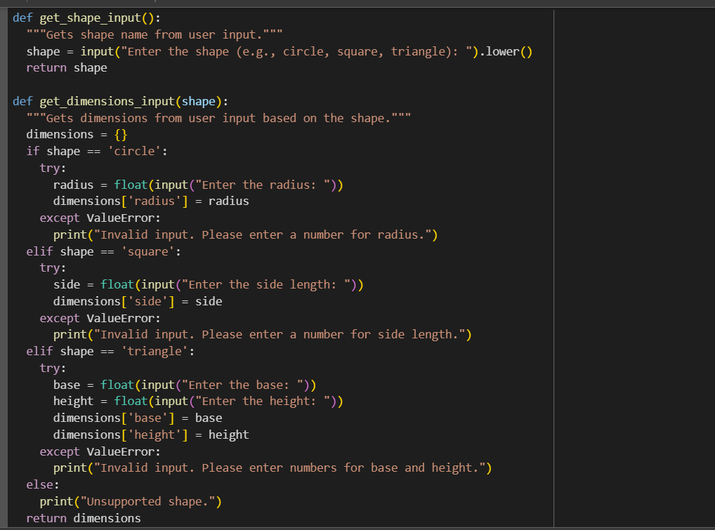

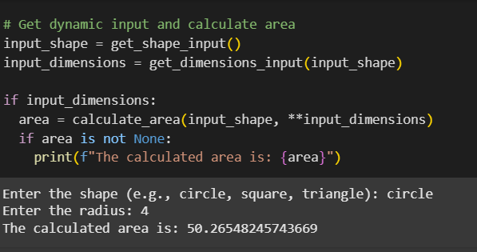

**Output:**



**Task Description#4**

* Install and configure Cursor AI. Use it to generate a Python function (e.g., sum of squares).

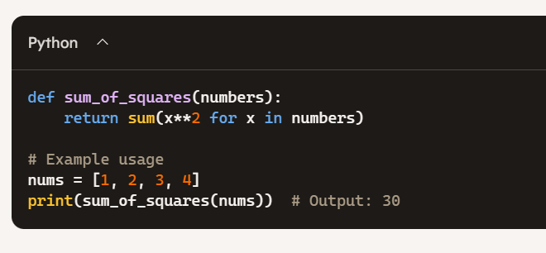

**Task Description#5**

* Student need to write code to calculate sum of add number and even numbers in the list

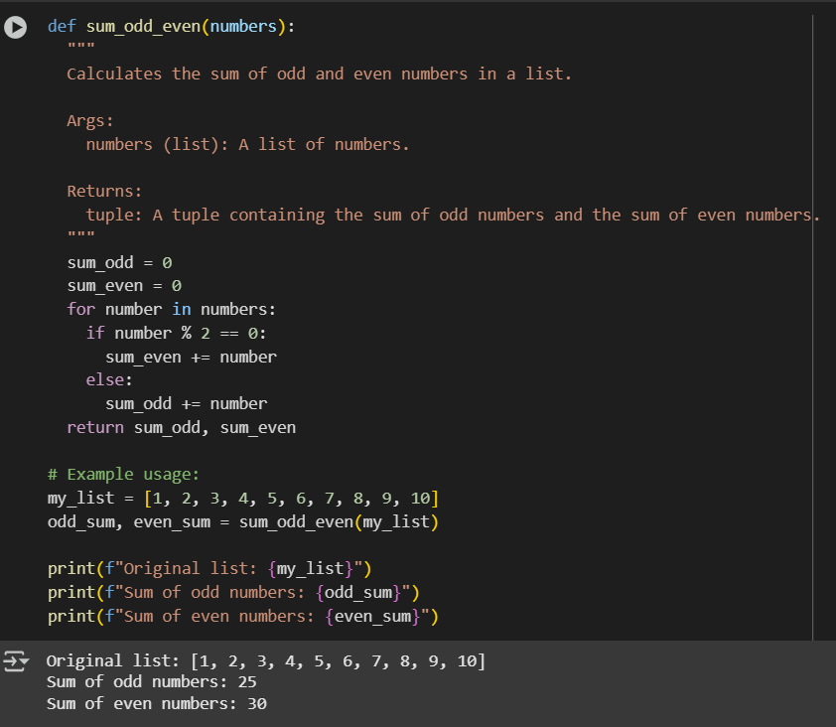

**Ouput:**

